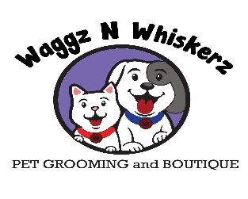
Pet Grooming Release Form

Pet’s Name: _________________

Your pet is important to us. Because we care, we want to assure you that every effort will be made to make your pet’s visit as pleasant as possible. Due to the unpredictable nature of animals, situations arise that are unexpected. Please initial any of the following pertaining to your pet.

____ Medical Condition: Occasionally grooming can aggravate an already existing medical condition. I have informed Waggz n Whiskerz of any/all medical conditions that they should know about. Should any medical situation arise I advise Waggz n Whiskerz to do whatever is necessary for the safety of my pet, this includes taking him/her to a veterinarian for evaluation at my cost.

____ Senior Pet: I understand that senior pets (age 7+) have a higher chance of injury.

____ Matted Pet: Because my pet is severely matted and or tangled, it is a greater risk of injury. Stress, and Trauma. All precautions will be taken to ensure the safety of my pet; however problems may arise such as nicks, clipper burn, irritation, mental and or physical stress.

I have read all of the information in this document and have initialed the appropriate sections for my pet. I have also read the liability and payment document sent VIA email or have signed a paper copy and agree to terms and conditions.

Owners Name: Date:
Signature:

